Running the 3065 Report for MH/D POAs

- In ChildPlus, go to the Reports Tab
- Click on Health
- Select Report 3065- Health Event Status
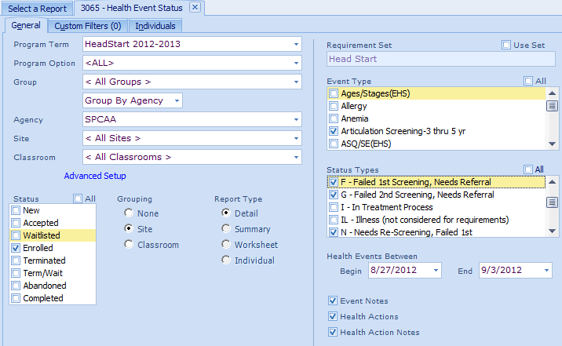
13
12
11
10
9
8
7
6
5
4
- Program Term: Select HeadStart or EarlyHeadStart and the correct program year.
- Site: Select your site from the drop down menu.
- Status: Enrolled should be the only status selected.
- Grouping: Select how you want the report grouped- by Site or by Classroom
- Report Type: Detail
- Event Type:
  - For Head Start- mark the boxes next to ALL of the following:
    - Articulation Screening- 3 thru 5,
    - ASQ:SE(HS)- 3 thru 5,
    - MHD concerns- parents/recruitment, and
    - MHD concerns- physical.
  - For Early Head Start- mark the boxes next to ALL of the following:
    - ASQ:SE (EHS),
    - MCHAT- 18 month,
    - MCHAT-24 month,
    - MHD concerns- parents/recruitment, and
    - MHD concerns-physical.
- Under Status Types, select all of the following:
  - F-Failed 1st Screening, Needs Referral
  - G-Failed 2nd Screening, Needs Referral
  - N-Needs Re-Screening, Failed 1st
  - OAI-Obtain Additional Information
- Enter the first day of school (8/27/12) for the Begin date.
- Enter Today’s date as the End date.
- Make sure all 3 boxes are checked (Event Notes, Health Notes, Health Action Notes)
- Click Preview.

This is how it should look if it is complete and has all the Actions needed:
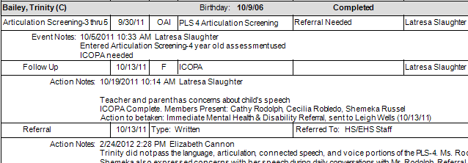
Child did not pass screening, had an ICOPA, and a Referral- all of the steps are entered.

This is how it will look if the POA has not yet been done:
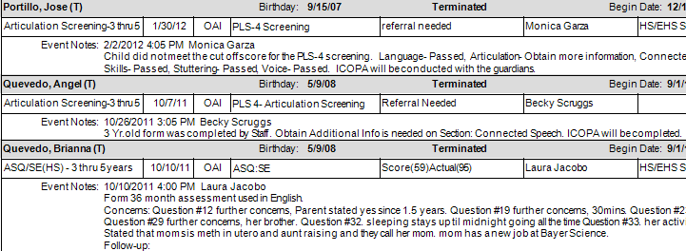
These children did not pass screenings, but there are no follow up actions (i.e. POA, Referral) entered in Child Plus.

